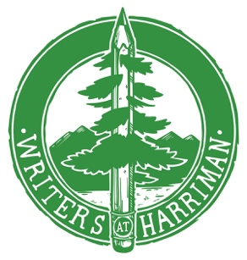

Writers at Harriman Parent/Student Agreement

Please initial and sign each of the following items. Doing so indicates your permission for Writers at Harriman to act as indicated, if needed.

Student: ________________________________ Date:______________

____ I, the student named above, do grant Writers at Harriman permission to use material I submit for the anthology online and in print, understanding that I will be credited, though not paid

____ I understand that receipt of my tuition payment secures my place at Writers at Harriman 2017. Confirmation of your payment and receipt of the permission page will be made by email. Tuition is $175. If you paid a $25 application fee, that goes toward your tuition. Unless you have received a scholarship, please send a check for the remaining $150, along with this agreement page to:

Writers at Harriman
PO Box 2525
Boise ID 83701

Parent or guardian, your response to each of the following items indicates your consent.

____ I grant the Writers at Harriman staff authority to render judgment concerning medical assistance or hospital care in the event of an illness or injury to my student. I understand that I will be notified as soon as possible should such occur.

____ I grant the Writers at Harriman staff authority to reproduce and use my student’s image for marketing and/or publication online or in print.

____ I have read the information about what my student needs to bring to camp and what he/she can expect, which is on the FAQ page of writersatharriman.org.

Parent/Guardian: ______________________________Date: _____________

Emergency contact 1: ____________________________Phone: ____________

Emergency contact 2: ____________________________Phone: ____________

Scan and email to writersatharriman@gmail.com or mail to the address above.

